# ***Challenge Name :- Checkout - apni dukaan***

**Description:** Welcome to the Checkout Challenge! You've landed on an eCommerce platform. Your goal is to explore the website thoroughly to find the hidden flag.

**Level:** Hard

**Solution:**

Welcome to the ecommerce store!

Navigate the eCommerce platform known as "Checkout" with keen attention to detail. Employ fuzzing techniques and careful page analysis to uncover the admin panel. Utilize brute force methods to gain access to the admin panel and unveil the hidden flag.

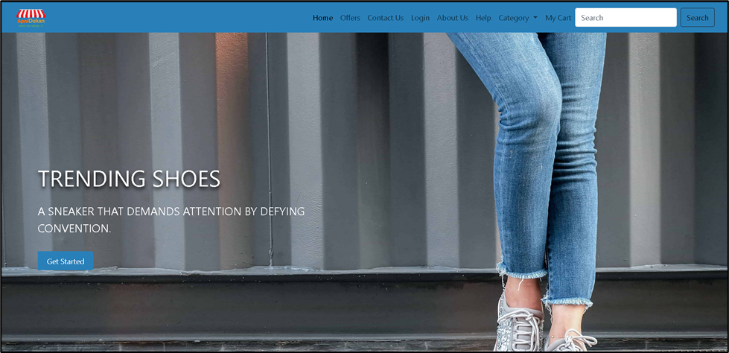

Begin by navigating through the various pages of the eCommerce platform.

/about.html

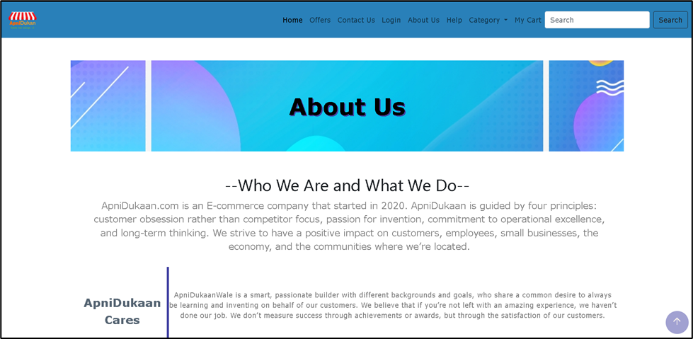

/cart.html

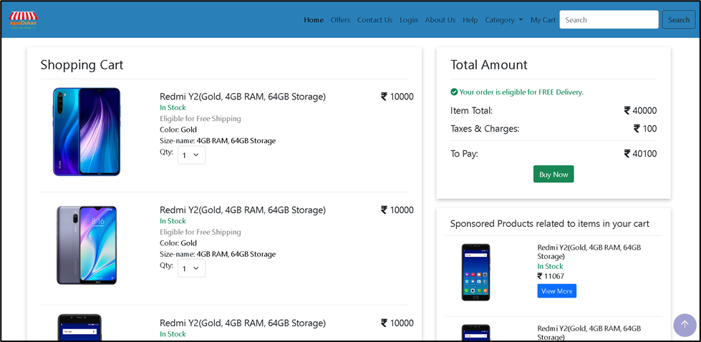

Examine each page carefully, looking for any text or elements that stand out. Check the source code for any clues or hidden information.

/home.html

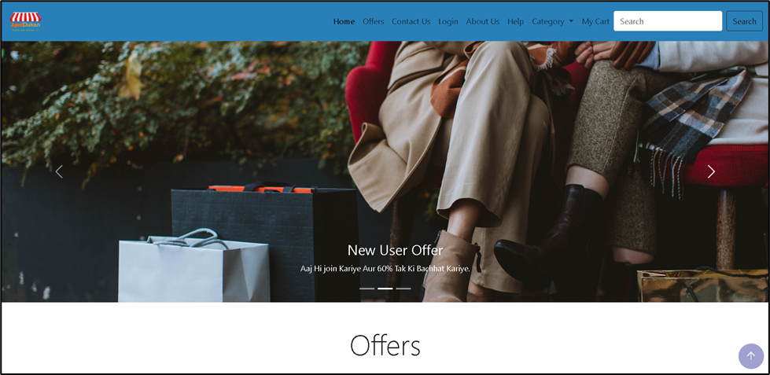

/contactus.html

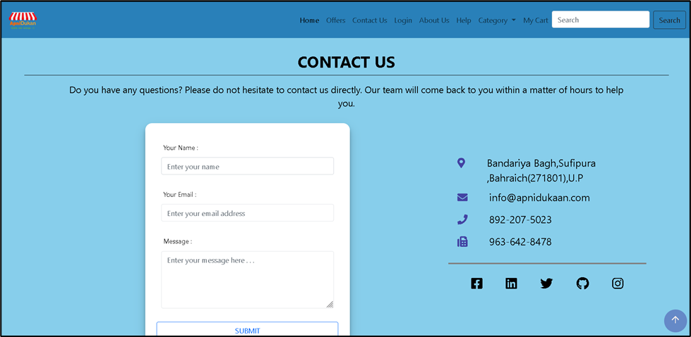

Try clicking on different links and buttons to see if they reveal any hidden functionalities or lead to additional pages.

/mobile.html

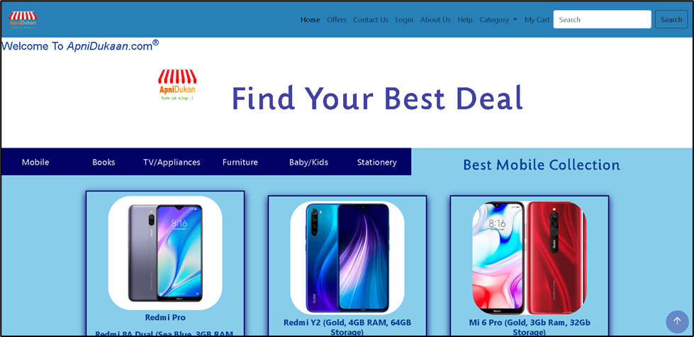

/help.html

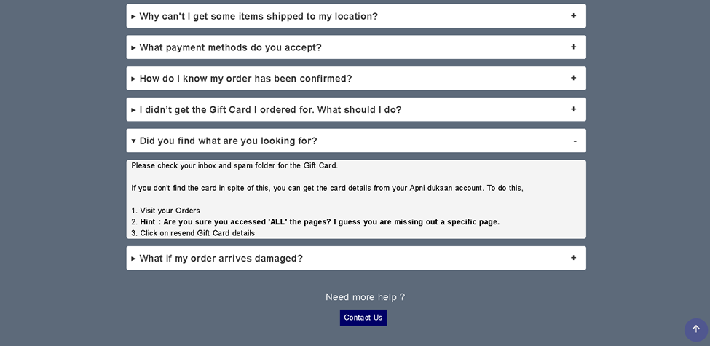

Here, I have provided a mini hint.

/privacy.html

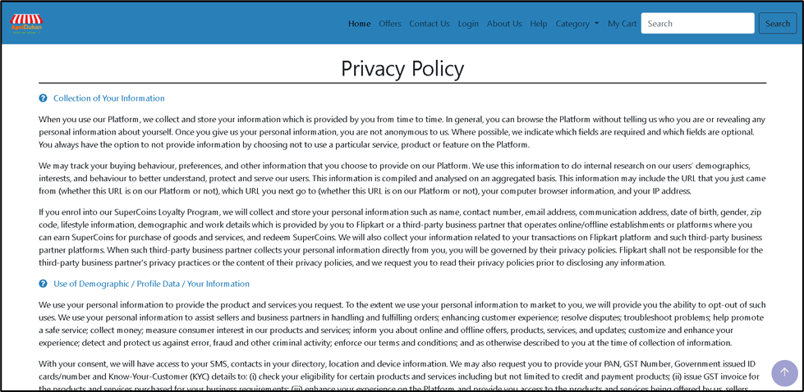

Similarly, find out more pages.

/faq.html

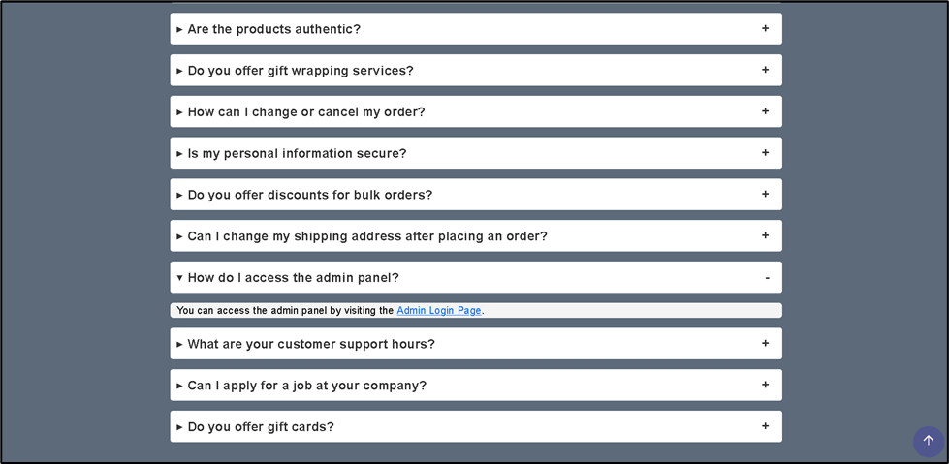

Pay special attention to the FAQ page. Read through all the FAQs thoroughly, as they may contain hints or clues leading to the flag.

Explore the website methodically, clicking on every accessible link and exploring every section to ensure no area is left unexamined.

If you discover a link or reference to an admin panel within the FAQ section, click on it to access the admin login page.

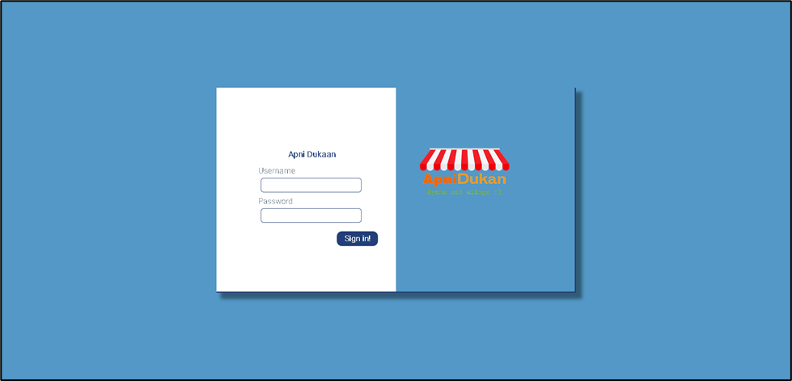

Use brute-force techniques to guess the login credentials for the admin panel. Try common usernames and passwords, or use automated tools to speed up the process.

Username – admin

Password – dragon

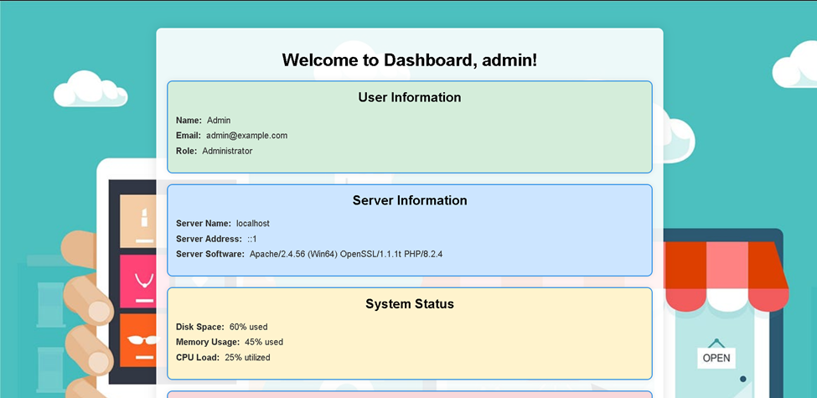

Now, check page source.

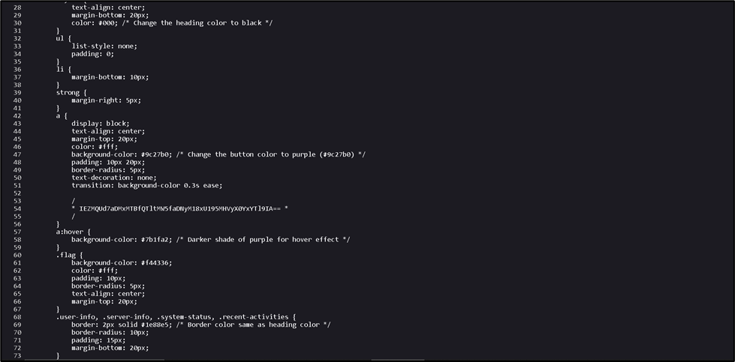

The flag is encoded.

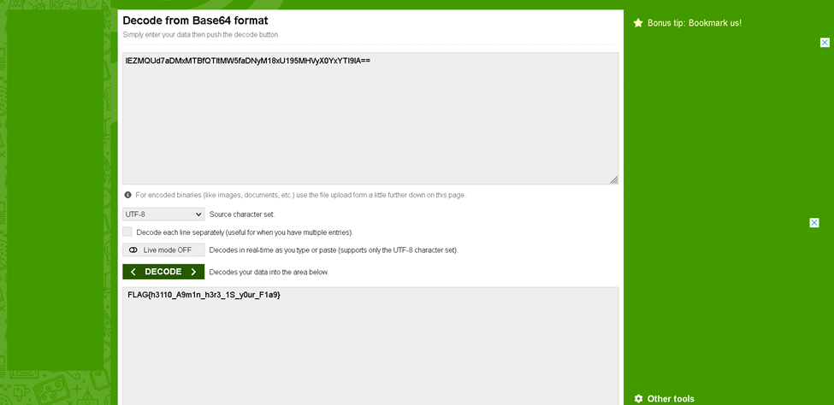

FLAG{h3110_A9m1n_h3r3_1S_y0ur_F1a9}

Once you believe you've found the flag, take a moment to validate your discovery.

Congratulations!

This page is intentionally left blank